2.

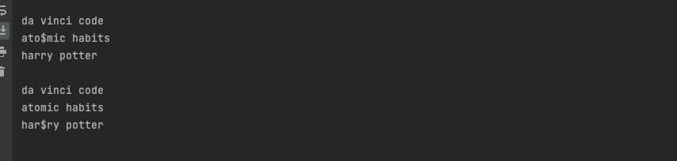

3.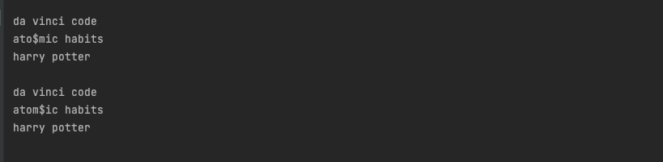

4.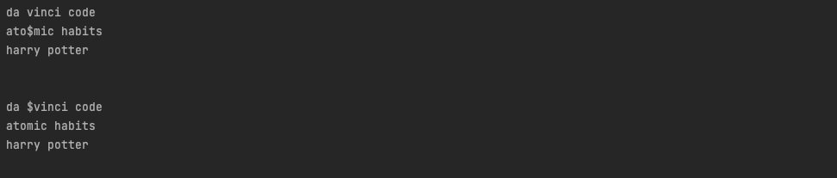

5.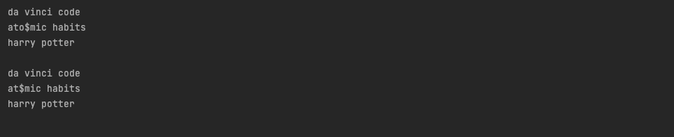

9.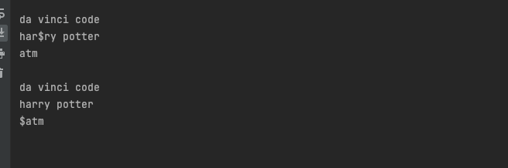

10.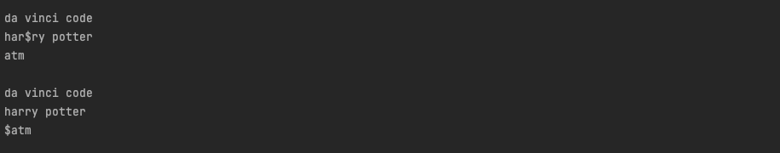

11.

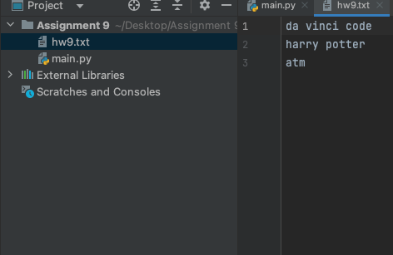

13.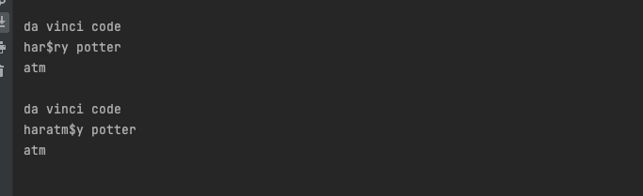

15.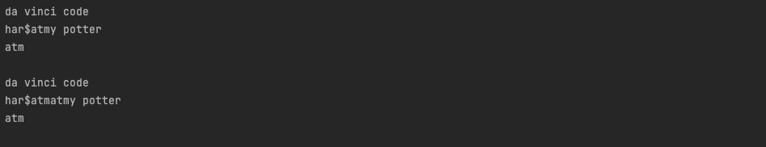

16.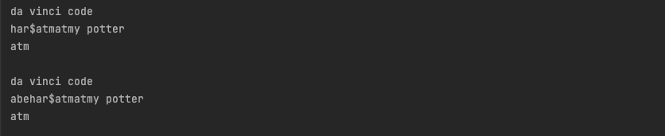

19.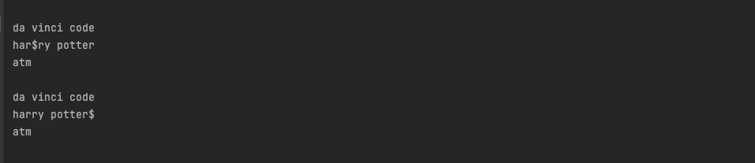

20